UNITY IN THE HETEROGENEITY
(Non-verbal theatre workshop)
with Juraj Benčík, the former White Clown in the Cirque de Soleil
The location: Hronov (Czech Republic) as a part of the biggest amateur theatre festival in the Czech Republic ‘Jiraskův Hronov’
28th July – 5th August 2023

We invite all those interested in non-verbal forms of theatre (e.g. pantomime) to the workshop as a part of the biggest Czech amateur theatre festival ‘Jiráskův Hronov’.
Go through the workshop with internationally respected Slovak teacher, actor and director, watch a pile of (not only) Czech amateur theatre performances, meet plenty of new friends and find lots of unforgettable experiences.

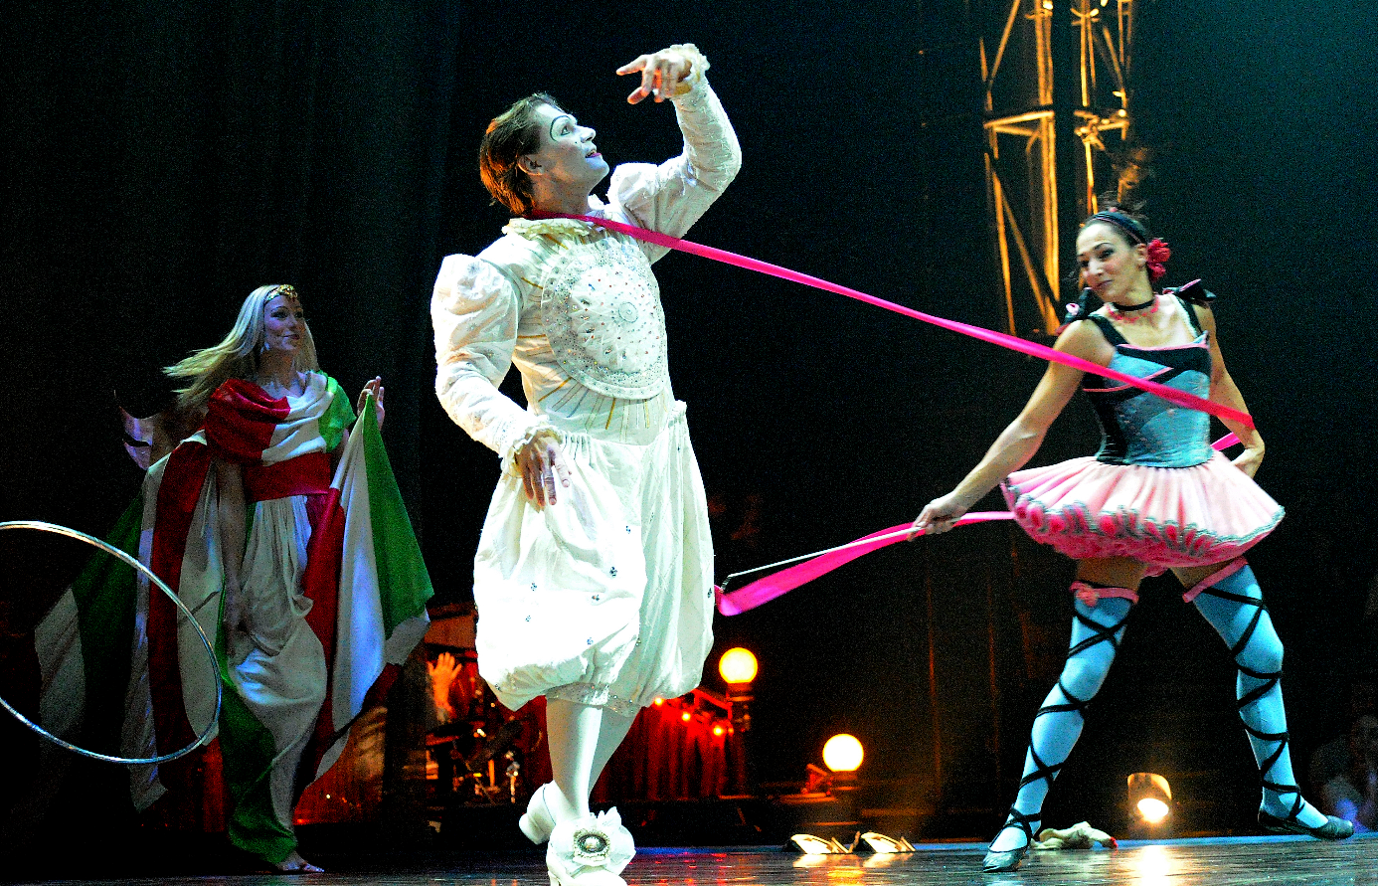We have a lot of topics that are troubling us. That separate us – the Europeans. We can be divided into tribes – Anglo-Saxons, Romanics and Slavs, where the source of our culture is the fourth tribe – Hellenic... We have Christianity (inspired by Judaism) but even that divides us to Catholics and Protestants, to Roman and Greek Catholics, to Calvinists, Augsburg Lutherans, Anglican Church, Orthodox Church...! We have even the non-Christian religions – Islamism, Hinduism, Taoism, Buddhism, Shinto... etc. We have the regional culture-historical, social and political units – Scandinavia, Benelux, Baltics, V4, the Balkan, the Mediterranean. We have political states! New, young – Slovakia, Slovenia, North Macedonia – and also ancient states, former world imperia – Spain, Portugal, France, Britain. We have the languages as well. Twenty-eight various language cultures with their own grammar, vocabulary and mutual attempts of equivalent translations. Three sets of writing and two of numbers. What should unite us, actually? The dissention of our historical experience to the fascists and anti-fascists in the first half of the 20th century – or the dissention of the experience to the communists and anti-communists in the time of the Cold War after the 2nd World War in the second half of that century? Or we can look at the last ten years of the 20th century of the luxuriant development of the mutual relationships in the field of economy, social and cultural life, which we today often understand as mutual bothering, abuse, threatening and violation? Or to our attitude to the recent political situation, to the war on Ukraine, to economic problems and to the possible green future of the mankind?. What can unite us as the joint topic at the one table? Is it the territory? Continent? Is it business – the common processes at the production? The mutual lines in the traffic and communication? Is it the universality of humanity? Is it the fear from different cultures, religions or continents? Is it the effort to understand mutually, to get to know each other, to create the common life, home, beauty, prosperity – or more likely the effort to be stronger against the threats from behind the boarders of the common space? What is the main source of our efforts to be together? And what is the main source of our efforts to split to... tribes, religions, historical, cultural, political and economic groups and wholes? How can we effectively and progressively understand the term UNITY IN THE HETEROGENEITY? Where starts the co-operation culminating in mutual enrichment and where the co-operation ends with its transformation to the conflict dividing us? Where is the starting point of the mutual bothering, abuse, threatening and violation?

Let’s search that fragile boarder-lines of the vulnerability and let’s display them through the theatre activity.
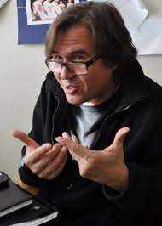
JURAJ BENČÍK

Juraj Benčík – actor, mime, director and teacher. He was a co-worker of Milan Sládek, Slovak mime and director. Worked in many professional theatres in Slovakia and abroad as an actor and director. Works for various TVs, as an organizer of big cultural events and almost two years played as White Clown in the famous Cirque du Soleil.

Teacher of workshop at 15. Mondial du Theatre in Monaco 2013; teacher in various art schools (state and private) in the Slovak and Czech Republics, many workshops for amateur theatre makers at Czech festivals.

www.jurajbencik.sk

Terms and conditions:
Hronov, 28th July – 5th August 2023
Workshop 4-5 hours a day, than (in the afternoon/evening) performances of the festival.
Working language: English
Arrivals:
- Friday 28th July until 2 p.m. (airport) or 3 p.m. (main train station) – in these times the coach transport to Hronov (about 160 km north-east from Prague at the Polish border) is organized.
- For adventurers or neighbours (by car, train or bus): Individual transport direct to Hronov or Náchod (bigger city 8 km from Hronov where the accommodation will be organized). Individual transport is on your own costs.
At 4 p.m. starts the registration in Hronov and in the evening there will be the first information meeting of participants of all workshops.

The complete workshop will finish by a presentation (together with other workshops) for the audience on Saturday 5th August in the morning.
The Festival will end by last performance and fireworks or video-mapping on 5th August in the evening.

Departures: Coach transport back to the Prague will be organized on Sunday 6th August early morning (arrival to Prague at about 10.30 a.m. (main station) or 11.30 a.m. (airport).

The participation fee: EUR 650.00 covers the workshop, accommodation (student home in Náchod, rooms in two or three persons), collective transport Prague-Náchod-Prague in abovementioned times, daily local transport between Náchod and Hronov, lunch and dinner each day (no breakfast), admittance to the main program Festival performances.
Payment after your application and the confirmation letter (IBAN/SWIFT will be written) by bank transfer or (in exceptional and agreed cases) in cash on site.

What is necessary to take with you: such kind of wear, you can do exercises in (even on the floor – for the nonverbal theatre is it often used something black, it’s universal), good humour.

Don’t forget to take out the travel insurance (and find the information about the conditions of health care for your travel). If your country has visa requirement for the Czech Republic, arrange for it.
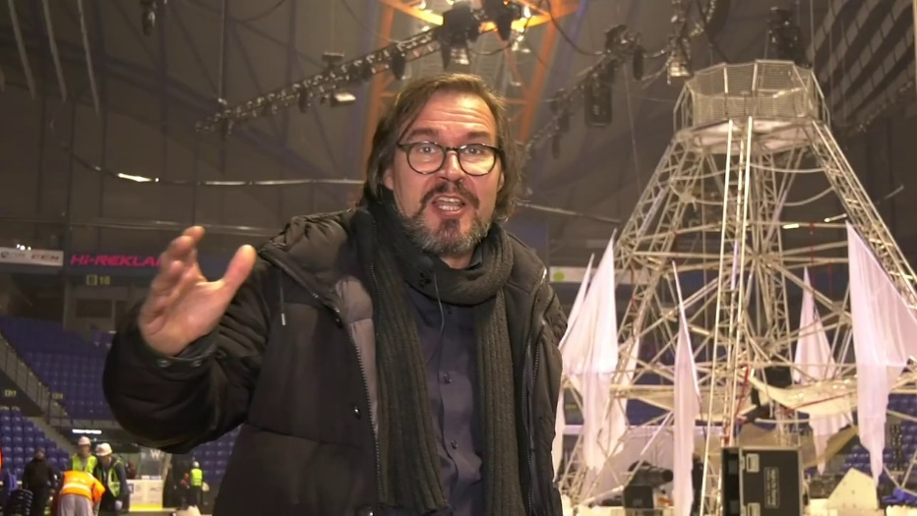
Deadline for the application is 30th April 2023!!
Applications via email to tomas@nipos.cz.
České středisko
NIPOS, P.O.Box 12/Fügnerovo nám. 5,
120 21 Praha 2, République Tchèque - Czech Republic - Tschechische Republik
cz
aita
iata
mezinárodní organizace amatérského divadla
Le Centre Tchèque de la
Association internationale du théâtre amateur
Czech Centre of
International Amateur Theatre Association
Tschechisches Zentrum des o
Internationalen Amateurtheaterverbandes

Phone: +420 221 507 932, +420 778 702 378, e-mail: tomas@nipos.cz
President: Lenka Lázňovská laznovska@nipos.cz, Secretary/Administrator: Karel Tomas tomas@nipos.cz

APPLICATION FORM
I apply to be a participant of the international workshop
“UNITY IN THE HETEROGENEITY”
(Practical non-verbal theatre workshop)
in the frame of the Festival “Jiraskuv Hronov”
Czech Republic, Hronov, 28th July – 5th August 2023

Please, write in BLOCK CAPITALS!
Surname: _____________________ First name(s): ________________________________
Sex: _______F/M______ Year of birth: __________________________________________
Home address: ______________________________________________________________
___________________________________________________________________________
Country: ___________________________________________________________________
Mobile/Phone: ________________________ Email: ____________________________
Dietary restrictions (vegetarian, gluten-free,...): ____________________________________
Transport: via Prague Airport with organized transport to/from Hronov
via Prague Main Station with organized transport to/from Hronov
Individual
(Arrival 28th July 2020, Departure 6th August 2023)
I agree with the participation fee (according the terms and conditions of the event) in the high of EUR 650.00.

Signature:
Please, fill in this application form and send it (via email as a text file or scanned) to the address tomas@nipos.cz before 30th April 2023.

